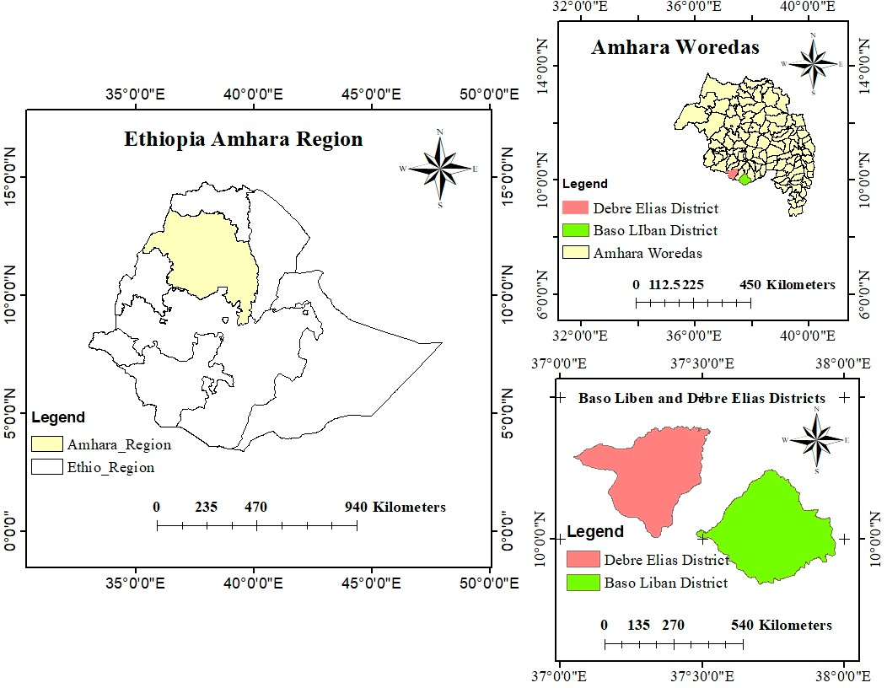

Figure 1: Map of the Study Area